VPC CHALLENGE
Use Case: Setting up Transit Gateway and VPC Endpoints for a Multi-VPC Architecture
Scenario:
A large organization is migrating its on-premises infrastructure to the AWS cloud.
The organization's architecture involves multiple VPCs for different departments and applications, each requiring secure communication with centralized services and external resources.
The IT team needs to design and implement a scalable and efficient network architecture to accommodate the organization's growth and ensure robust connectivity between VPCs and external services.
Objectives:
- Design and deploy a scalable network architecture using AWS Transit Gateway to simplify network connectivity between multiple VPCs.
- Configure VPC endpoints to securely access AWS services without internet gateways or NAT gateways, ensuring data privacy and minimizing exposure to external threats.

Set up a VPC Transit Gateway.
Create multiple vpc in the region with public subnets and total configuration
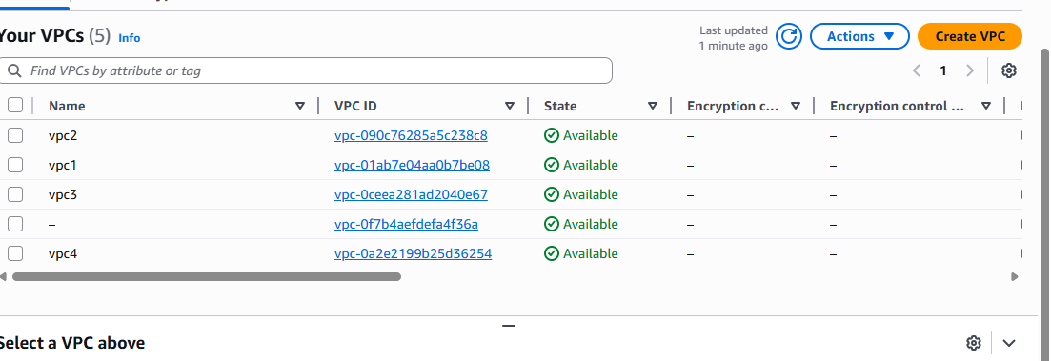

Create the instances by using which we created vpc’s earlier
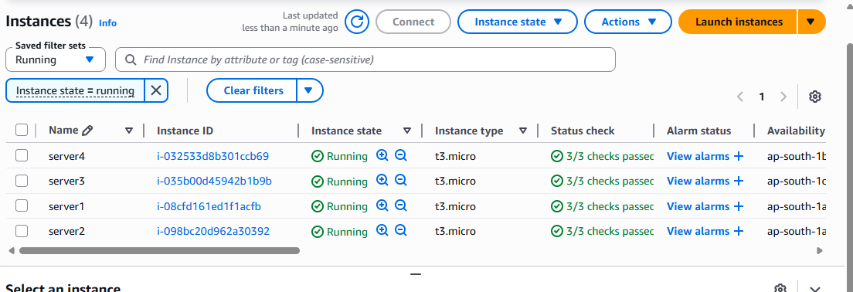
Create transitgateway
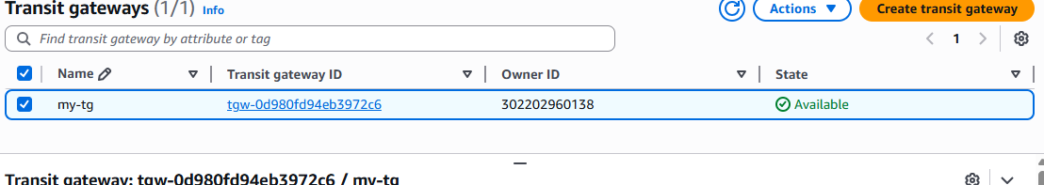
Create transit gateway attachments and attach to the vpc
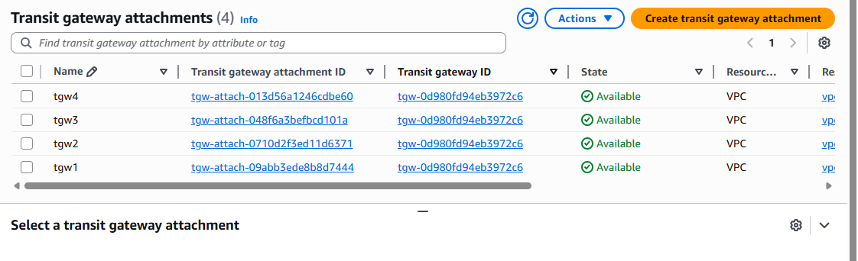

Check the transit gateway route table weather the attachments are associated with the route table
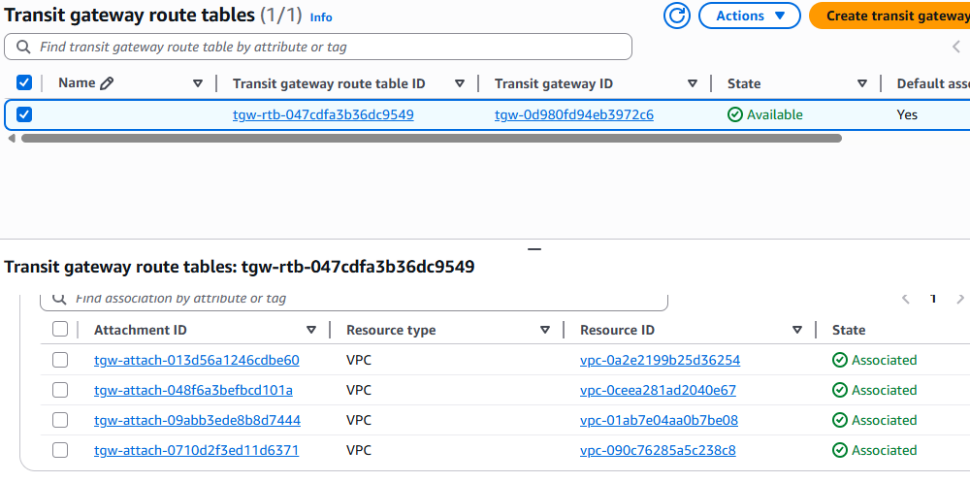
Coming to the route table of the vpc and the all CIDR’s in all route tables
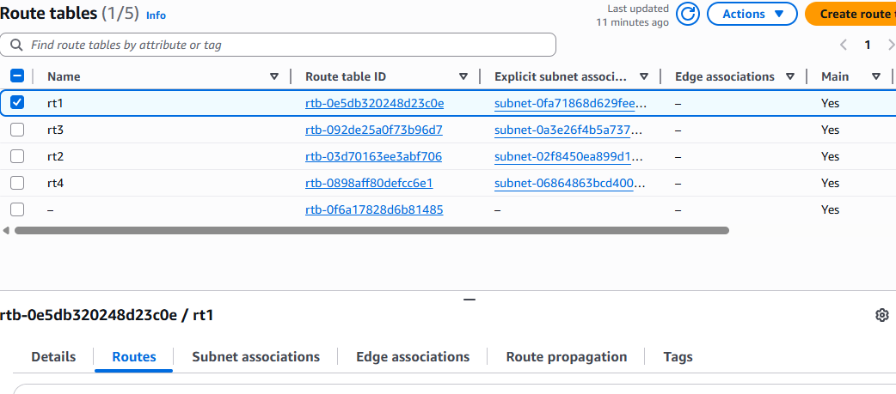
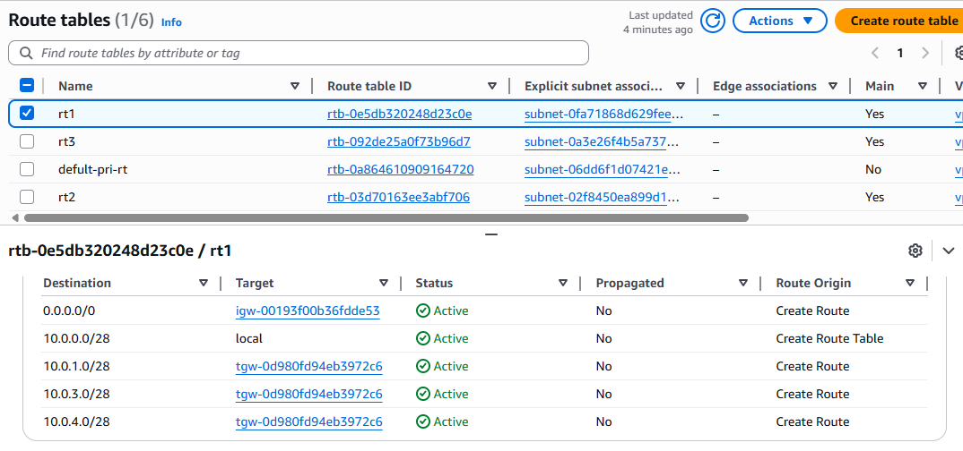
Connect to the one instance which we are created and check the connectivity different instance by using [ping command and private Ip address


- Set up a VPC Endpoint.
Crate end point
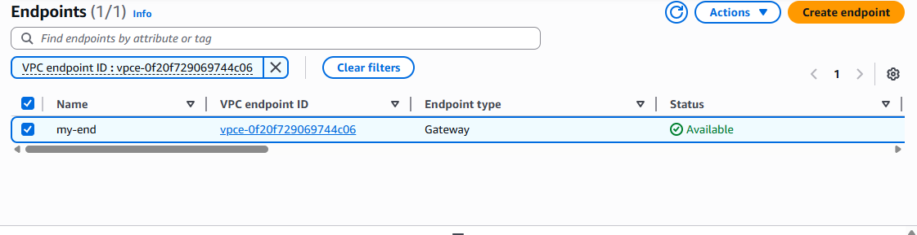

Select the s3 service and click the gateway
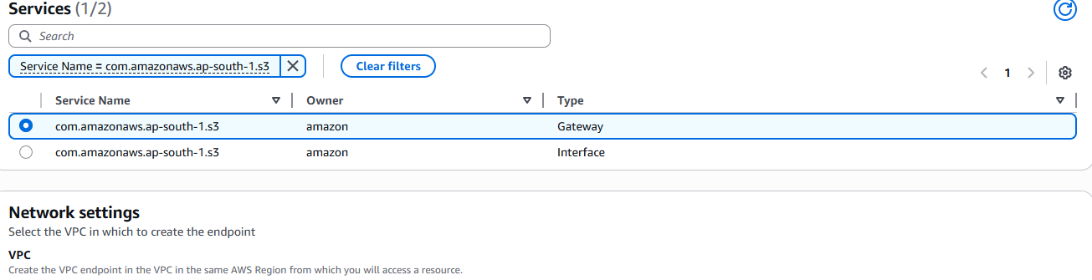
Add the vpc which you are using vpc for launch th eprivate instance.
add the private route table and click the create.
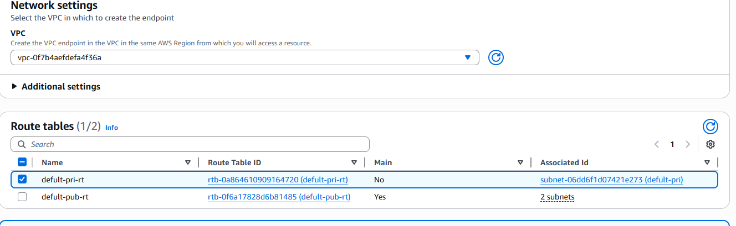
we can check the private route table and you will see the one route is created
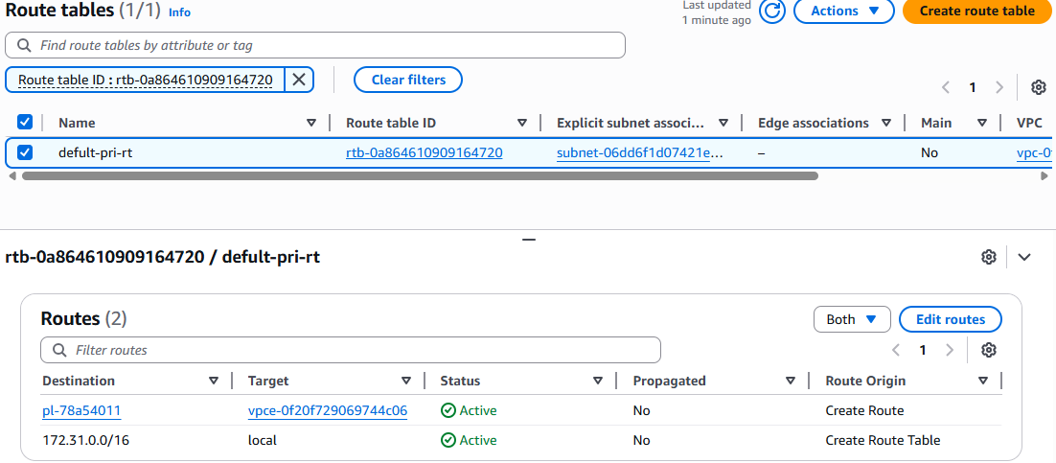

Here we can check through the aws CLI or git bash, without NAT gateway we are able to accessing the private instance
